**PS Lab 6**

**IT24102180**

**Assalaarachchi B.T**

**Exercise**

1. An IT company claims that their newly developed learning platform improves student performance in online tests. According to previous data, 85% of students who used the platform passed their online tests. A batch of 50 students is selected at random who have completed the course using this platform. Let X denote the number of students who passed the test out of 50 students.

i. What is the distribution of X?

* Binomial Distribution

ii. What is the probability that at least 47 students passed the test?

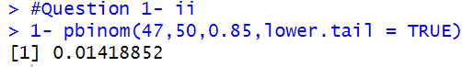

2. A call center receives an average of 12 customer calls per hour.

i. What is the random variable (X) for the problem?

* X- number of calls received in an hour

ii. What is the distribution of X?

* Poisson Distribution

iii. What is the probability that exactly 15 calls are received in an hour?

